PERTH MODERN SCHOOL


Trial WACE Examination, 2012

Question/Answer Booklet

MATHEMATICS SPECIALIST 3C/3D

Section Two:

Calculator-assumed

Student Number: In figures

In words

Your name

Teacher

Time allowed for this section
Reading time before commencing work: ten minutes
Working time for this section: one hundred minutes

Materials required/recommended for this section

To be provided by the supervisor
This Question/Answer Booklet
Formula Sheet (retained from Section One)

To be provided by the candidate
Standard items: pens, pencils, pencil sharpener, eraser, correction fluid/tape, ruler, highlighters

Special items: drawing instruments, templates, notes on two unfolded sheets of A4 paper, and up to three calculators satisfying the conditions set by the Curriculum Council for this examination.

Important note to candidates

No other items may be used in this section of the examination. It is your responsibility to ensure that you do not have any unauthorised notes or other items of a non-personal nature in the examination room. If you have any unauthorised material with you, hand it to the supervisor before reading any further.

Structure of this paper

Section | Number of questions available | Number of questions to be answered | Working time (minutes) | Marks available | Percentage of exam
Section One:  Calculator-free | 7 | 7 | 50 | 50 | 33
Section Two:  Calculator-assumed | 13 | 13 | 100 | 100 | 67
 |  |  | Total | 150 | 100

Instructions to candidates

- The rules for the conduct of Western Australian external examinations are detailed in the Year 12 Information Handbook 2012. Sitting this examination implies that you agree to abide by these rules.

- Write your answers in the spaces provided in this Question/Answer Booklet. Spare pages are included at the end of this booklet. They can be used for planning your responses and/or as additional space if required to continue an answer.
- Planning: If you use the spare pages for planning, indicate this clearly at the top of the page.
- Continuing an answer: If you need to use the space to continue an answer, indicate in the original answer space where the answer is continued, i.e. give the page number. Fill in the number of the question(s) that you are continuing to answer at the top of the page.

- Show all your working clearly. Your working should be in sufficient detail to allow your answers to be checked readily and for marks to be awarded for reasoning. Incorrect answers given without supporting reasoning cannot be allocated any marks. For any question or part question worth more than two marks, valid working or justification is required to receive full marks. If you repeat an answer to any question, ensure that you cancel the answer you do not wish to have marked.

- It is recommended that you do not use pencil, except in diagrams.

Section Two: Calculator-assumed (100 Marks)
This section has thirteen (13) questions. Answer all questions. Write your answers in the spaces provided.

Working time for this section is 100 minutes.

Question 8 (6 marks)
In two residential suburbs, A and B, from 1984 to 1999, the median house price, 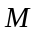 dollars, increased at a rate given by 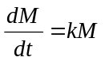, where is the time, in years and is a constant specific to each suburb.

For suburb A, the median price at the start of 1984 was $55 300 and prices were observed to double every 9.5 years. For suburb B, the median price at the start of 1989 was $74 100 and prices were observed to double every 8.5 years.

In which year was the median house price the same in both suburbs?

Suburb A, with 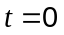 in 1984:
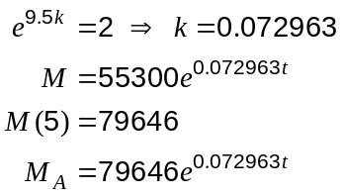

Suburb B, with in 1989:
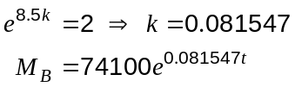

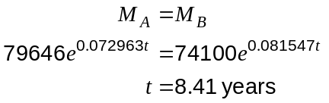

Hence prices the same during 1989+8 = 1997.

Question 9 (5 marks)
The following Leslie matrix, , applies to a population of beetles in which the female beetles in the population live for a maximum of 3 years and only propagate in their third year of life.

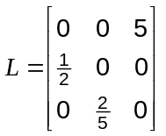

(a) What is the probability that a newborn female beetle will survive to the 3rd year of its life?
(1 mark)
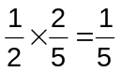

(b) Initially there are 500 females in each age group. How many females will there be altogether after 2 years? (2 marks)
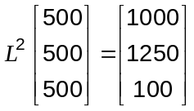

Total = 2350 beetles

(c) Comment on the long-term population of female beetles predicted by this model. (2 marks)

The total number of female beetles starts at 1500 initially, then nearly doubles after 1 year to 2950, falls back to 2350 after 2 years and then returns to 1500 after 3 years, with 500 in each age group as at the start of the cycle.

This cycle then repeats endlessly, according to the model.

Question 10 (7 marks)
(a) A triangle with vertices at 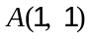, 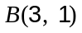 and 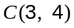 is reflected in the -axis and then rotated 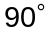 anticlockwise about the origin.

(i) Find the matrix that will combine these two transformations in the order given.
(3 marks)

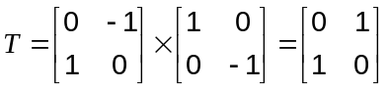

(ii) Find the coordinates of  after transformation by . (1 mark)

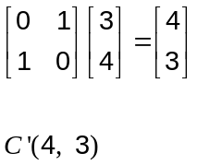

(b) Another transformation matrix is given by 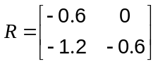.

Determine the area of triangle 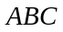 after it has been transformed by and then by . (3 marks)

Original area of triangle ABC = 3 sq units.

Determinant of T is -1, so no change in area.

Determinant of R is 0.36, so final area 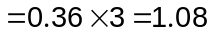 sq units.

Question 11 (7 marks)
A function is defined as 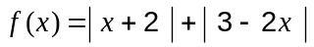.

(a) Express  without the use of absolute value bars. (3 marks)

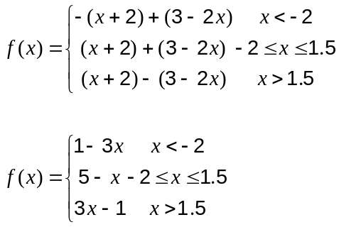

or f(x) = 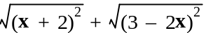

(b) Sketch the graph of (2 marks)
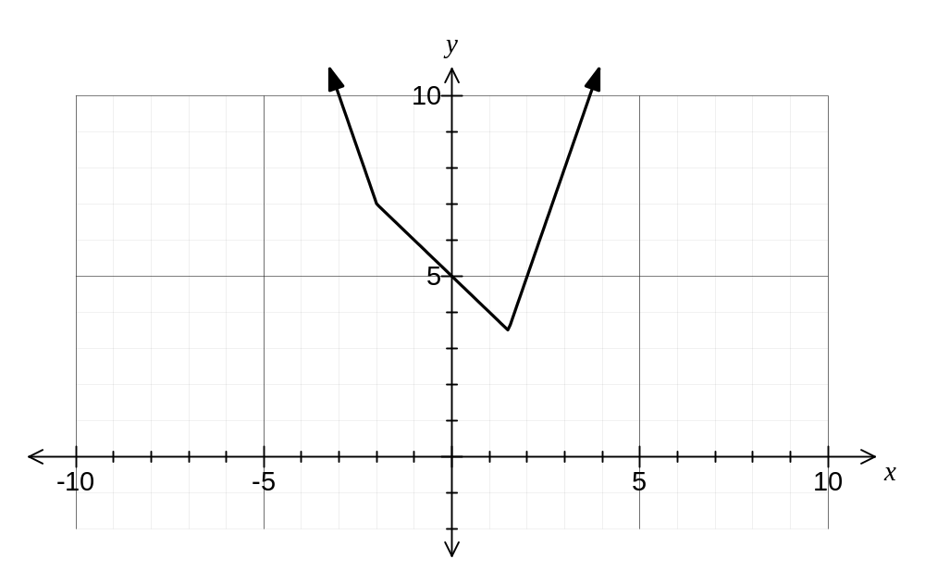

(c) Solve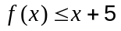. (2 marks)
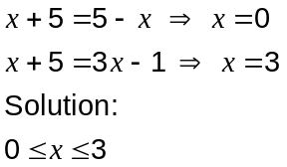

Question 12 (6 marks)
Find the exact area bounded by the -axis, the -axis, the function 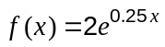 and the tangent to when 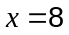.
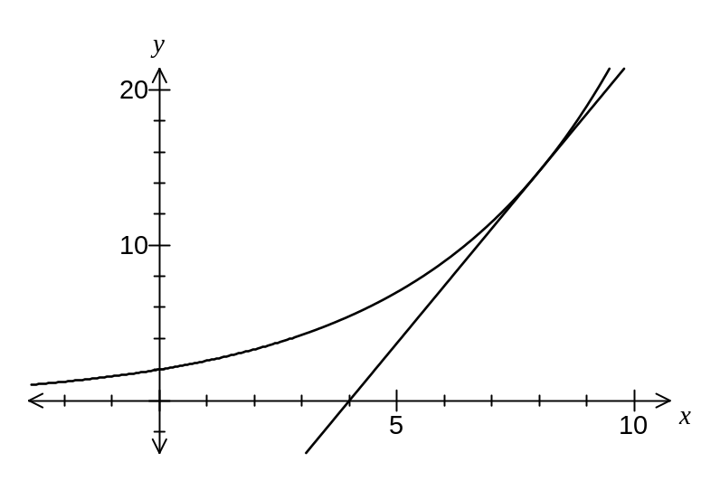

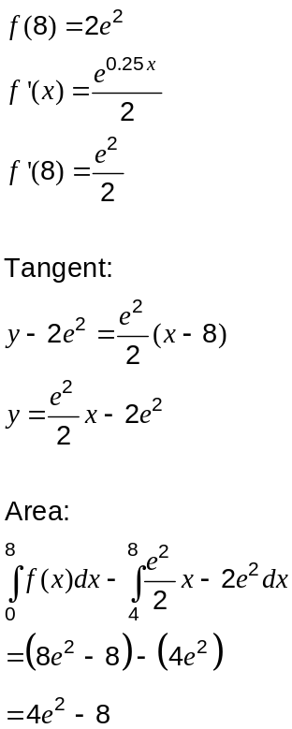

units²
Question 13 (6 marks)
A light is positioned at the top of a vertical post 12 m high. A small ball is dropped from the same height as the light but at a point 4 m away.
If the distance travelled by the ball seconds after release is given by 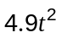, how fast is the shadow of the ball moving along the horizontal ground half a second after the ball is dropped?
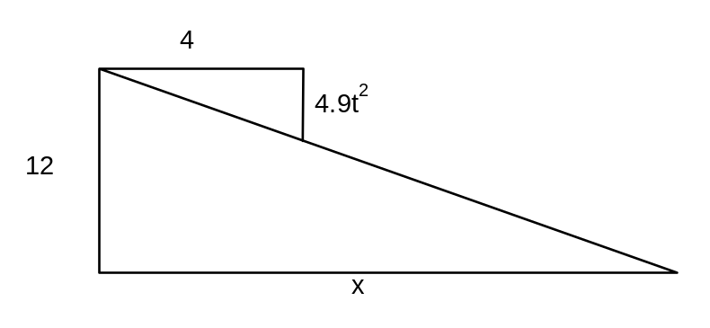
Find 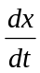 when 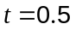.

Using similar triangles,
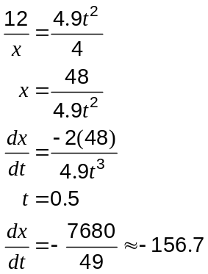

Hence speed of shadow is 156.7 m/s.

Question 14 (8 marks)
(a) Use proof by contradiction to prove that 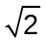 is irrational. (4 marks)

Assume that is rational and can be written as the simplified fraction 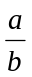, where and are integers with no common factors.

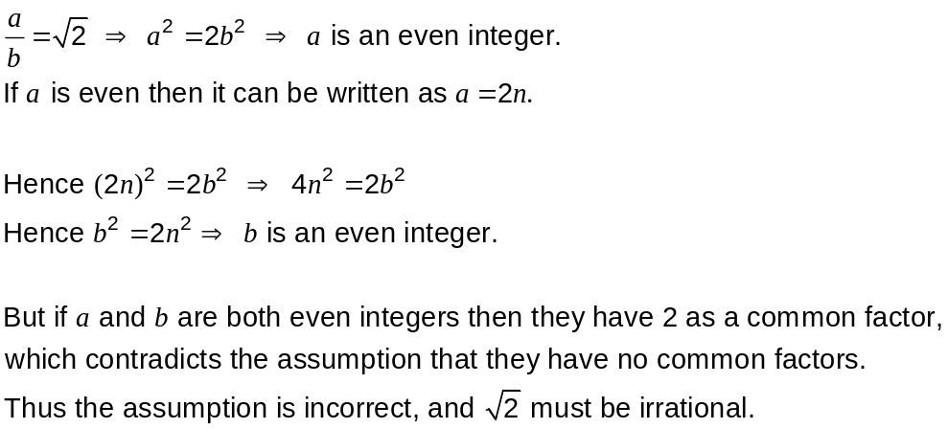

(b) Use a vector method to prove that the diagonals of the rhombus OPQR are perpendicular.
(4 marks)

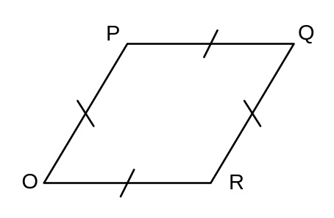

Let 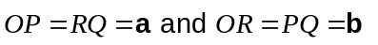.

Then 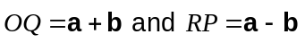.

So dot product of diagonals is

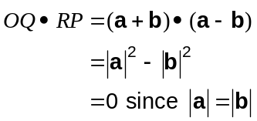

Hence the diagonals are perpendicular.

as OPQR is a rhombus
Question 15 (12 marks)
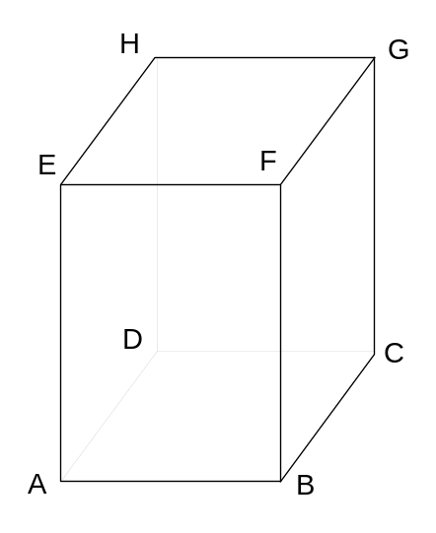ABCDEFGH is a rectangular prism with

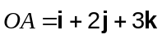

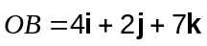

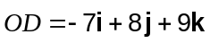

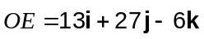

(a) Find a vector equation for the plane EFGH in the form . (3 marks)
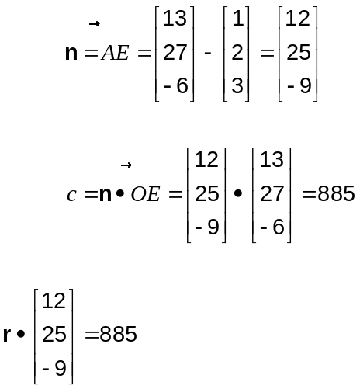

(b) Find a vector equation for the line passing through A and E. (2 marks)

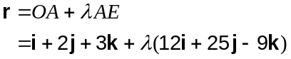

(c) The point P lies on the line through AE so that the size of 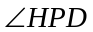 is 90°. Find the shortest possible distance from A to P.
(7 marks)

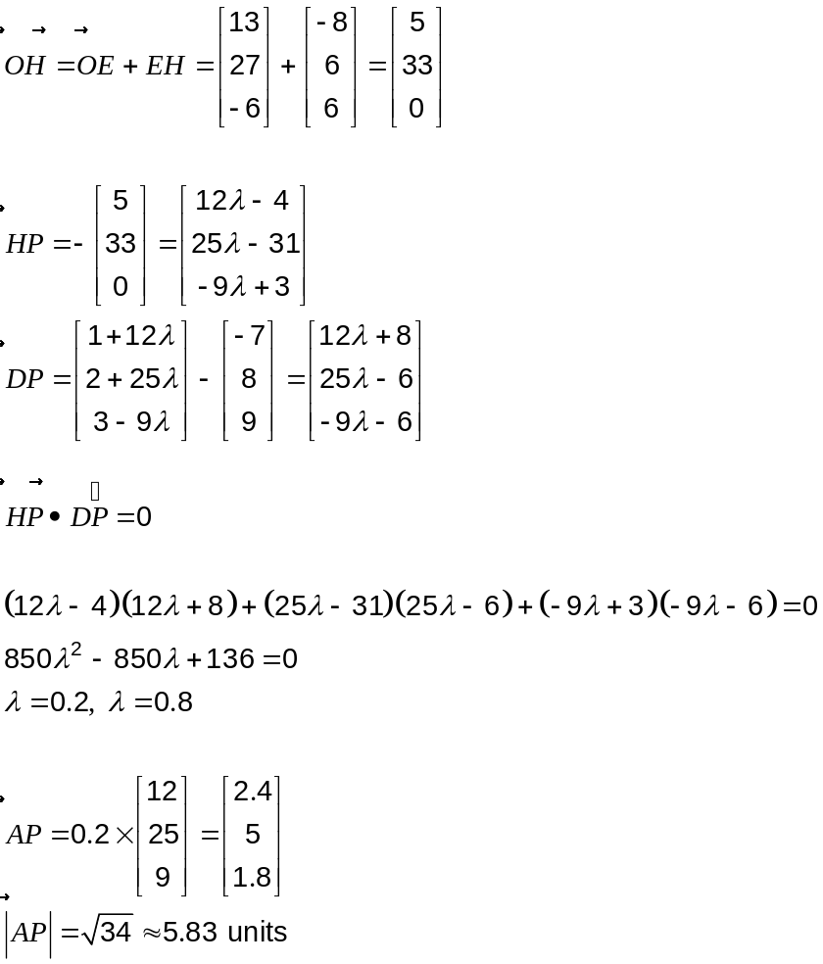

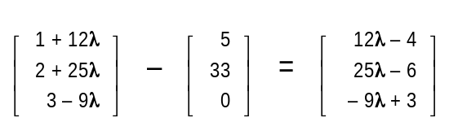

-
-
Question 16 (9 marks)
Let 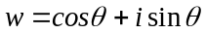 and 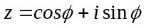.

(a) Use Euler's formula to express the product in exponential form. (1 mark)

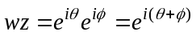

(b) Use and to show that . (4 marks)

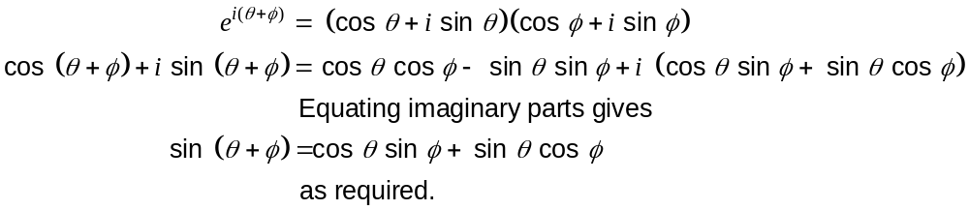

(c) Hence show that 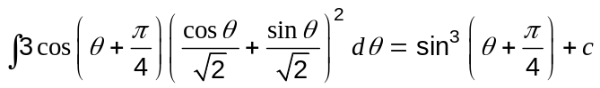. (4 marks)

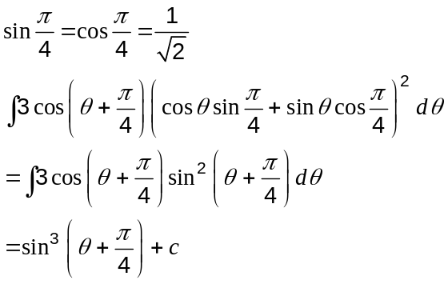

Question 17 (8 marks)
A particle moves along the -axis, with displacement cm from the origin, after seconds, given by 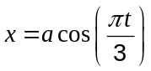 , where is a positive constant. After 1 second, the particle is 12 cm from the origin.

(a) Find the value of . (1 mark)
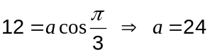

(b) Show that the motion of the particle is simple harmonic. (2 marks)
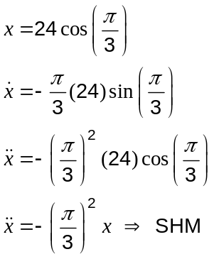

(c) Find the speed of the particle as it passes through the origin. (2 marks)

Maximum speed when passing through origin, so
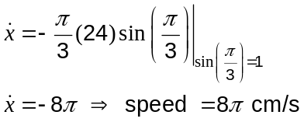

(d) Find the distance travelled by the particle during the first minute of its motion. (3 marks)

Period is 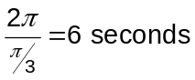, so in 60 seconds will move through exactly 10 cycles.

Amplitude is 24 cm, so in one complete cycle moves 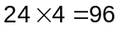 cm.

Hence will travel 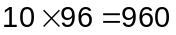cm.
Question 18 (9 marks)
A complex inequality is given by 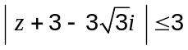.

(a) Sketch the region in the complex plane defined by this inequality. (3 marks)

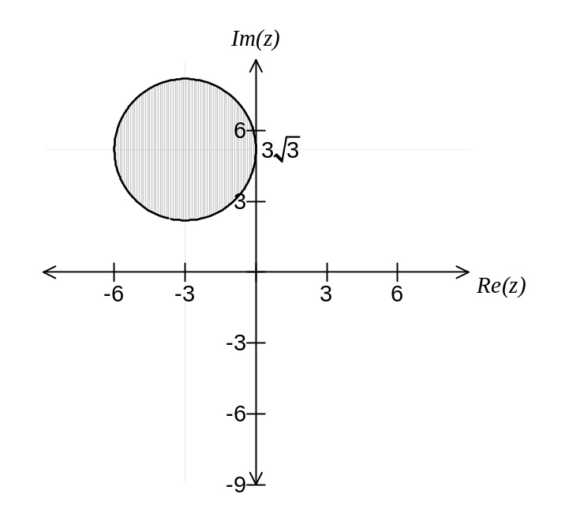

(b) Find the minimum and maximum values of 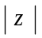. (3 marks)
Radius of circle is 3.
Distance from (0, 0) to circle centre is 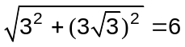.
Min is 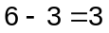
Max is 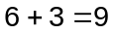

(c) Find the minimum and maximum values of 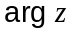. (3 marks)
Minimum value is 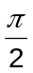.

Maximum value is 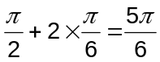.
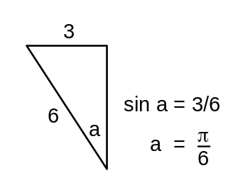

Question 19 (10 marks)
The velocity of a body moving in a straight line is given by 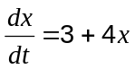, where is the displacement, in metres, from a fixed reference point at time seconds. When 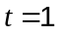, 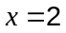.

(a) Find an expression for in terms of . (5 marks)

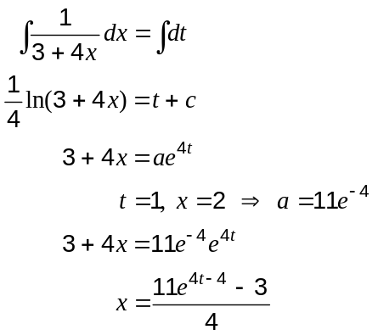

(b) What is the exact velocity of the body when

(i) 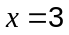? (1 mark)
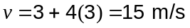

(ii) 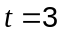? (2 marks)
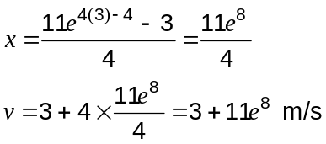
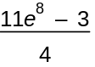

11e⁸

(c) What is the acceleration of the body when ? (2 marks)
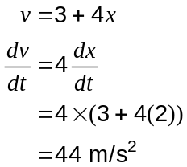

Question 20 (7 marks)
Let 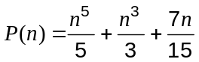.

(a) Evaluate 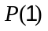 and 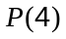. (1 mark)

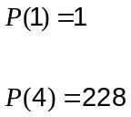

(b) Prove by induction that 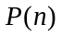 is always an integer, when is a positive integer. (6 marks)
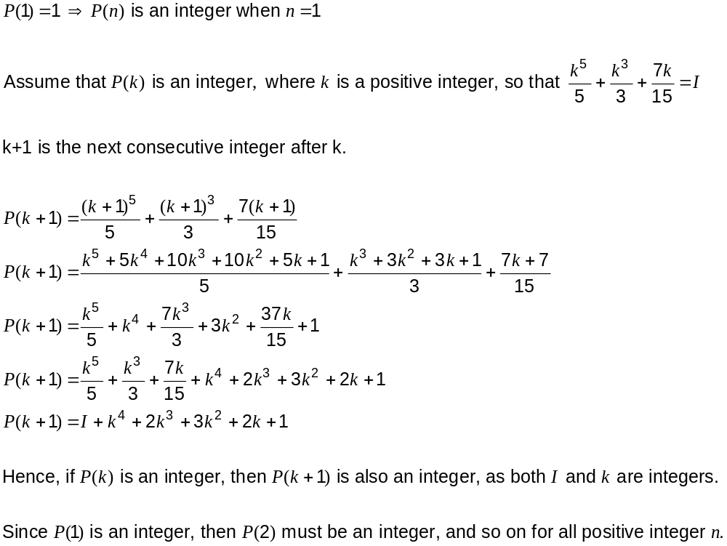

Additional working space

Question number: _________

Additional working space

Question number: _________

Additional working space

Question number: _________

This examination paper may be freely copied, or communicated on an intranet, for non-commercial purposes within educational institutes that have purchased the paper from WA Examination Papers provided that WA Examination Papers is acknowledged as the copyright owner. Teachers within purchasing schools may change the paper provided that WA Examination Paper's moral rights are not infringed.

Copying or communication for any other purposes can only be done within the terms of the Copyright Act or with prior written permission of WA Examination papers.

Published by WA Examination Papers
PO Box 445 Claremont WA 6910

